Body Presencing : Healing the Root of the Matter
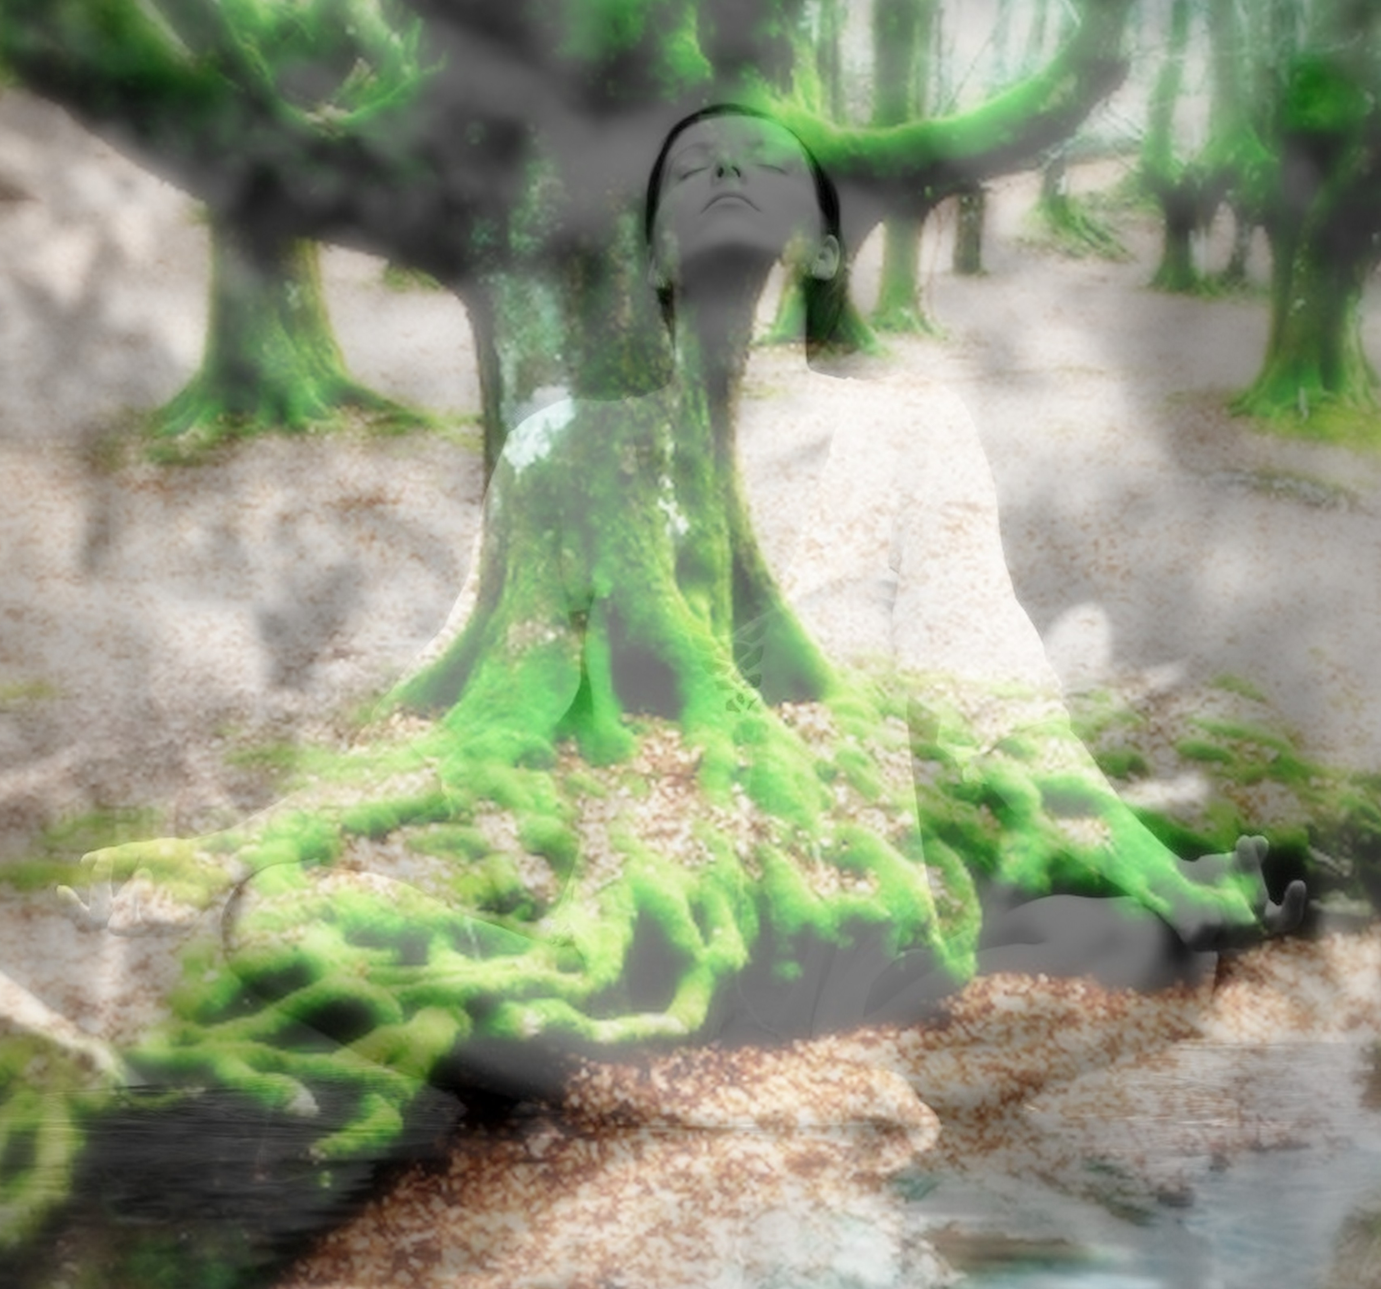

APPLICATION

If you are ready to live a more passionate, vital, and healthy life then fill out this application and fax it back to me at 314-995-3922. If you don’t fully understand any of these questions, you can leave them blank and we will review them together when we meet.

- How long have you had the intention or goal of becoming more passionate, healthy, and whole?

- What actions have you taken to become healthier, more passionate and whole?

- What other options (besides working with me) have you explored?

- What outcome would you like to experience after our work together?

- What are you willing to do to experience more passion, vitality, and health?

- Give me three words that best describe how you view yourself or how you operate in this world?

- Who are you closest to in your family and why?

- What things have occurred in your family (i.e. early deaths, people leaving, accidents, losses, stillborns and miscarriages) in the last three generations that contribute to your wanting greater levels of health, wholeness, and passion?

- Is there anyone you blame for your sense of self or your life choices?

- What family messages were passed down from your family (i.e. only men matter, or its dangerous to get married, or I can’t be happy or successful)?

- Is there someone excluded or forgotten in your family (the black sheep, the father or grandfather who abandoned the family, the alcoholic or drug addict, etc)?

- What would you most like to change about yourself if you could?

- Do you have any personal secrets you are keeping from your family and others close to you?

- What is your primary complaint with your family or yourself?

- What do you think is keeping you from experiencing happiness, health, and passion in your life?

- Tell me why you are interested in this work? What event, trauma, or awakening has occurred in your life that has brought you to this place?

- On a scale of 1 – 10, how motivated are you to plumb your depths to find the light through the tunnel?

- Please fill out your full name, primary email address, phone number, and mailing address.

- What are the best times to reach you to begin this process together?

I will phone you within a calendar week to set up a mini consultation session. You may also contact me at: 314-995-9755 and I will return your call. Please leave your phone number and the best times to reach you. I look forward to working with you in the near future.

Healing the Root of the Matter,
Dr. Gail Cloud, DC

